Lab: Text Processing
Problems for in-class lab for the Python Fundamentals Course @SoftUni.
Submit your solutions in the SoftUni judge system at https://judge.softuni.bg/Contests/1739.

Reverse Strings
You will be given series of strings until you receive an "end" command. Write a program that reverses strings and prints each pair on separate line in the format "{word} = {reversed word}".

Examples
Input | Output
helLo  Softuni  bottle  end | helLo = oLleh  Softuni = inutfoS  bottle = elttob
Dog  caT  chAir  end | Dog = goD  caT = Tac  chAir = riAhc

Hint
Read the first line and create a while loop until you receive "end":
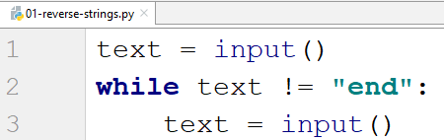
Now loop backwards through the text and add each character to a variable that stores the reversed string:
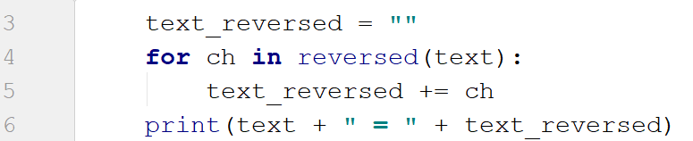

Repeat Strings
Write a program which reads a sequence of strings, separated by a single space. Each string should be repeated N times, where N is the length of the string. Print the final strings concatenated into one string.

Examples
Input | Output
hi abc add | hihiabcabcabcaddaddadd
work | workworkworkwork
ball | ballballballball

Hint
Start by reading the input and splitting it (we can receive multiple words):
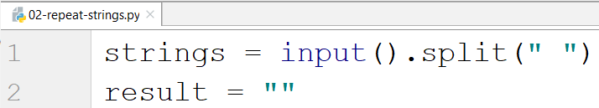
Loop through each word, get its length and add the repeated word to the result:
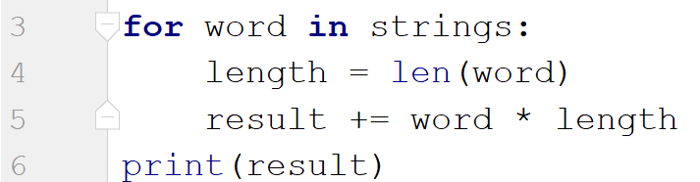

Substring
On the first line you will receive a string. On the second line you will receive a second string. Write a program which removes all the occurrences of the first string in the second until there is no match. At the end print the remaining string.

Examples
Input | Output | Comment
ice  kicegiciceeb | kgb | We remove ice once and we get "kgiciceeb"  We match "ice" one more time and we get "kgiceb"  There is one more match. The finam result is "kgb"

Hints
First read the two lines:
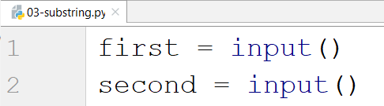
Create a while loop which replaces all occurrences of the string with empty string and print the result:
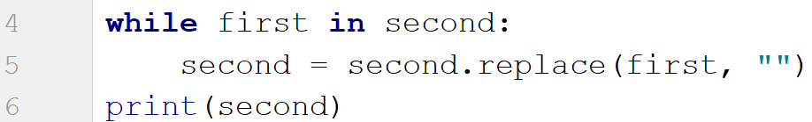

Text Filter
Write a program which receives a text and a string of banned words, separated by a comma and space ", ". All words included in the ban list should be replaced with asterisks "*", equal to the word's length.
The ban list will be entered on the first input line and the text - on the second input line.

Examples
Input | Output
Linux, Windows  It is not Linux, it is GNU/Linux. Linux is merely the kernel, while GNU adds the functionality. Therefore we owe it to them by calling the OS GNU/Linux! Sincerely, a Windows client | It is not *****, it is GNU/*****. ***** is merely the kernel, while GNU adds the functionality. Therefore we owe it to them by calling the OS GNU/*****! Sincerely, a ******* client

Hints
Read the banned words and the text:
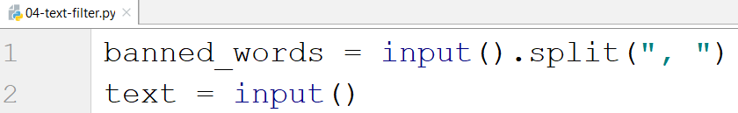
Loop through all the words and replace them with "*" while they are in the text:
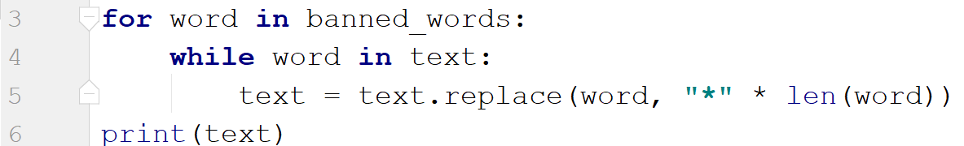

Digits, Letters and Other
Write a program which receives a single string. On the first line it should print all the digits found in the string, on the second – all the letters, and on the third – all the other characters. There will always be at least one digit, one letter and one other characters.

Examples
Input | Output
Agd#53Dfg^&4F53 | 53453  AgdDfgF  #^&

Hints
Read the input and create 3 empty strings for each type:
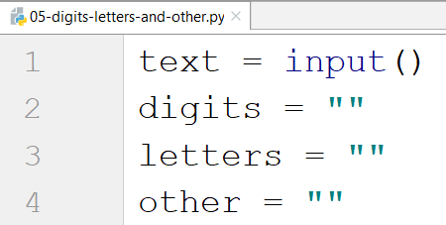
Loop through each character and check if it is digit, letter or other:
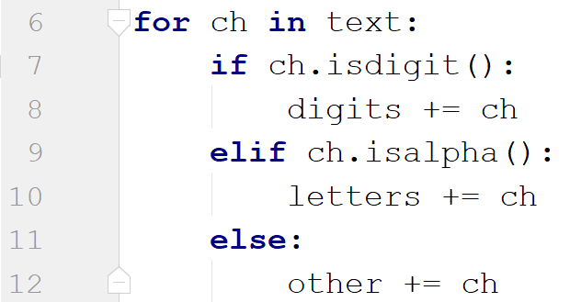
Print the result:
